EXPERIMENT NO. 01---PN SEQUENCES



Name: Amitalok J. Budkuley
Roll Number: 19034

Group
Member(s):
Jyothi Kiran (Roll Number here)
Kiran Jyothi (Roll Number here)

____________________________________________________

Design and Simulation Laboratory-Communication Systems
Department of Electronics & Electrical Communication Engineering
Indian Institute of Technology Kharagpur
____________________________________________________

TITLE: Design of Pseudo-Noise (PN) sequences using Linear Feedback Shift Register (LFSR) and applications of PN sequences.
_________________________________________________________________________________
PROBLEM STATEMENT: Design a 5-bit pseudo noise (PN) sequence generator using a linear feedback shift register (LFSR). In particular,
- Demonstrate a simple construction of a PN sequence.
- Now robustify the design by avoiding the `lockout’ condition (where all register states are set to ‘0’).
- Find the correlation function of the generated PN sequence by taking suitable shifted versions of the sequence.
- Using simple arithmetic (modulo-2) operations, construct, generate and demonstrate a Gold code sequence.
_________________________________________________________________________________
KEY COMPONENTS: IC7418(AND gate), IC7432(OR gate), IC7486(XOR gate), IC7495(4-bit shift register), IC74164 (8-bit shift register), digital oscilloscope, function generator, breadboard, connecting wires, power supply.
BRIEF THEORY & BACKGROUND:
The experiment's objective is to generate a pseudo-noise (PN) sequence through the utilization of a linear shift feedback register (LFSR) [1]. An LFSR functions as a generator of random number sequences, serving as a cipher within cryptography. PN sequences find frequent application in digital communication systems, oftentimes also approximating white noise. Often denoted as Pseudo-Random Binary Sequences (PRBS), PN sequences possess a `pseudo’ nature, indicating that their randomness is not absolute. Instead, they exhibit periodicity with the potential for a substantial period, showcasing characteristics of a random white sequence within this interval.
PN sequences arise from the assembly of a fixed number of flip-flops connected serially, coupled with combinational logic, typically in the form of XOR gates. The contents of the registers shift one bit to the right with each rising edge of the clock pulse. Simultaneously, the logic circuit computes a Boolean function based on the flip-flop states. This outcome loops back as input to the initial flip-flop, thus preventing the shift register from emptying. The resulting PN sequence is contingent upon factors like the number of employed flip-flops, the feedback circuit's logic, and the initial state. A comprehensive block diagram of the PN sequence is depicted below for reference.
<Add more as appropriate>

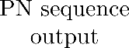
:

Figure 1: Block diagram of a typical PN sequence generator using an LFSR.

Properties of PN sequences:
The properties which make pseudorandom signal truly appears to be random are listed below:
- Balance Property: In each period of a maximum length sequence, the number of 1s is always one more than the number of 0s.
- Run Property: Among the runs of 1s and 0s in each period of a maximum length sequence, one half the runs of each kind are of length one-fourth are of length two, one eighth are of length three, and so on as long as these fractions represent meaningful numbers of runs.
- Correlation Property: Correlation is a measure of similarity between two sequences. When the two sequences compared are different it is the ‘cross correlation’ and when they are the same it is the ‘autocorrelation’.
- <Add more as appropriate>

Applications of PN sequence in communication and signal processing systems:
<To-do> In your final writeup, comment on the applications of PN sequences in communication systems and describe the application in a few words.

Expected Outcomes:
1. Utilizing an 8-bit linear feedback shift register, it becomes feasible to produce a PN sequence with a potential length extending up to 255 bits. Demonstrate a PN sequence using 5-bit shift registers, and comment on the size of the PN sequence generated. Check that the generated sequence adheres to the fundamental PN properties, including the run length, balance, and correlation properties. For the resulting output plot, include both the clock and the generated PN sequence on a common reference.
Note: to avoid the lockout condition, make the input to the first flip flop temporarily floating. This ensures that the initial state of the LFSR is not all-zeros.
2. Lockout conditions can force a PN sequence generator to “lock” itself to the all zero state where all shift registers are at “0” state. Given the combinatorial feedback logic, an LFSR in the all-zero state continues to be in that state unless acted upon by external inputs. Hence, it is pertinent to build accompanying protection to help avoid getting into the all-zero or lockout state. Design the circuit for lock-out protection.
3. For the stated problem (generation of a 5-bit PN sequence), the autocorrelation function's peak should exclusively manifest when the shift amounts to either zero or multiples of the generated PN sequence's period. Contrarily, during other instances, the correlation function remains consistently low, showing the minimum value. Consequently, the generated PN sequence should exhibit a favourable characteristic of elevated autocorrelation and diminished cross-correlation. Plot the autocorrelation function.
4. Gold sequences are widely used in spread spectrum communication. Here is a brief background, after which the specific problem follows:
Gold sequences are a special type of binary sequence that are generated by XORing two PN sequences. As we know already, PN sequences, or pseudorandom noise sequences, are binary sequences that exhibit some of the statistical properties of white noise, but are generated deterministically from a shift register with feedback. To generate a Gold sequence, we need to choose two same-length PN sequences with identical periods and a common generating clock. Once the two PN sequences are generated, the final Gold sequence is generated by XORing the PN sequences component-wise. The resulting Gold sequence will also have good autocorrelation properties, which makes it useful for applications such as spreading codes in CDMA systems.
- You need to design a length N = 127 sized Gold sequence.
- Draw a block diagram of the Gold sequence generation.
- Show a plot of the Gold sequence with respect to one of the underlying PN sequence.
- Can you comment on the autocorrelation property of the Gold sequence vis-a-vis the underlying PN sequences (which have a two-valued autocorrelation function, i.e., one “high” value and one low “value”)? Hint: it is more than 2-valued, i.e., it takes more than 2 values.
For software parts:
- Export the DSO data, i.e., time series in .csv format and plot it in MATLAB.
- Plot the autocorrelation function for the above data and comment on the generated function.
- In addition, generate a PN sequence with 6-stage Linear Feedback Shift Register and plot its autocorrelation function using the following polynomial:
x⁶ + x + 1
- Repeat step 3 for the following polynomial:
x⁶ + x⁵ + x⁴ + x³ + x² + x + 1
- Comment on the difference in the plots, if any, emphasizing, in particular, on the nature of the polynomials (irreducible and primitive, if any).
Note: Both hardware and software results should be included in the report. Standard MATLAB functions may be used.

APPENDIX
Appendix: List of Primitive Polynomials
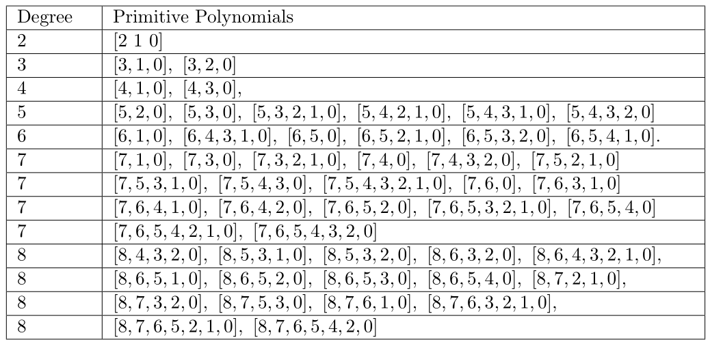

Note: Include PIN diagrams of all ICs used.

Mention (enumerate) all references including private communication, reference papers, public articles, etc.. Look up online resources to understand how references are cited.
References:
[1] Florescu, Dorian, and Ayush Bhandari. "Time encoding via unlimited sampling: Theory, algorithms and hardware validation." IEEE Transactions on Signal Processing 70 (2022): 4912-4924.
<This is only an example to indicate the referencing style. Make it a point to cite relevant work when discussing their contributions in your writeup.>

